**Coaching Report: Batter Pitch Mix**

*Written By Alex Kelleher*

**Summary**

The model created to predict batter pitch mix has an excellent correlation to next years pitch frequency. The model was created with the understanding that pitch count is one of the most significant factors to pitch mix regardless of who is at the plate. The model predicted season long data distributions for each player but there is also an attached file that has season long data predictions for each pitch count. The resulting data helps us understand how batters can be more accurately prepared for each pitch based on what count they are facing.

Implementing the model can tune the lineup to take advantage of the mix batters are expecting to see. Attempting to force pitchers to use their full arsenal regardless of what they might be the most comfortable with will provide an opportunity to see more of their less impressive offerings.

The final implementation step can be used to understand the opportunities or weaknesses in the Reds roster construction.

**Game Preparation**

Before each game the opposing pitcher needs their pitch mix analyzed. Not just their pitch mix but the pitch mix on each count. The 5th series of the Reds 2024 season was played against the Chicago White Sox. In the 15th game the opposing pitcher was Micheal Soroka. Soroka’s 2023 pitch mix is listed below. (Micheal Soroka was selected because of how simple the pitch mix was for this example)

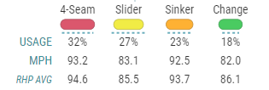

*Source: Baseball Savant*

The first takeaway is that he is only throwing 4 pitches, all 10% of the time or more. Sorting these into FB-BB-OS = 55%/27%/10%. When we combine this information with the distribution of Soroka’s pitch mix based on count a different picture arrises.

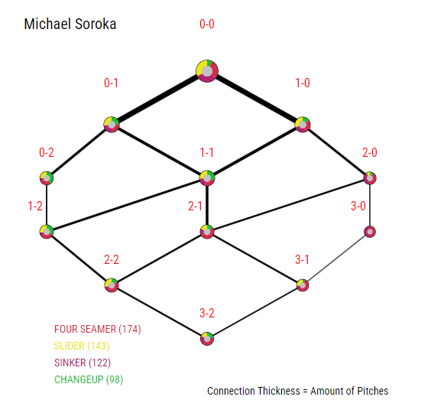

*Source: Baseball Savant*

The obvious counts for all players are going to be the 2-0,3-0, and 3-1 counts where a fastball is almost guaranteed. The pitcher counts are where the Reds batter pitch mix model comes into play.

The first two batters in game 15 of 2024 for the Reds were Jonathan India and Will Benson. The charts below show the pitch mix expectations based on the count for Jonthan India and Will Benson. Potential implementation of the more detailed model can be used on an individual at bat basis.

Jonathan India started the game by taking a sinker as strike 1. Looking at only Soroka’s pitch mix the odds of receiving a breaking ball in an 0-1 count decrease from 33% to ~25%. Based on the model India is in fact 4% more likely to see a breaking ball in an 0-1 count than an 0-0 count. This model while not designed to provide a 1 to 1 weight the pitch expectancy does help shift the expected outcome towards a breaking ball which in this at bat is what he received.

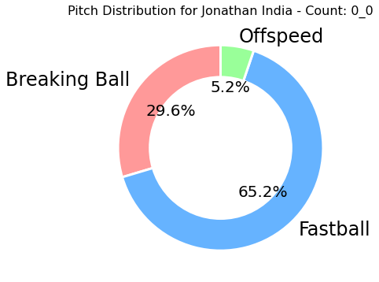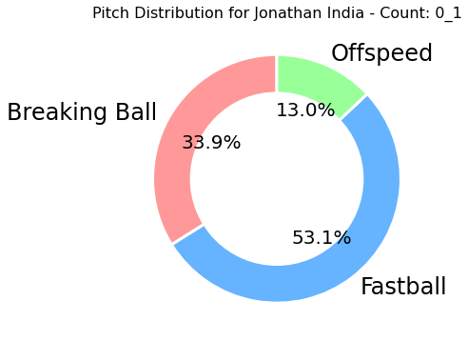

Will Benson has similar season long numbers to India with a noticeable jump in his Offspeed rate. Looking at a similar process for Will Benson who’s AB went: 1-0, 1-1, 2-1, 3-1, BB

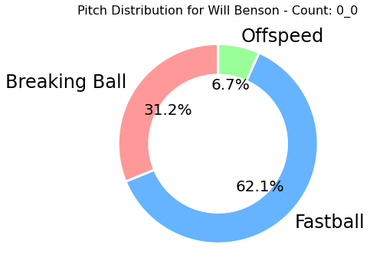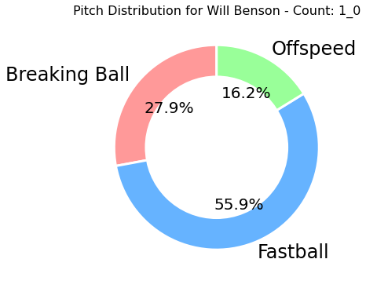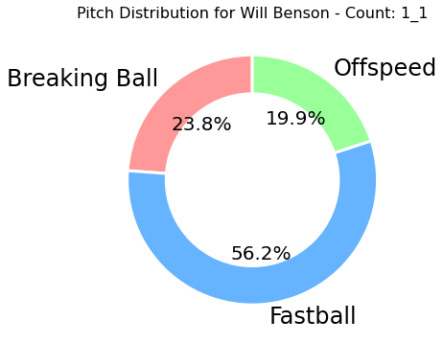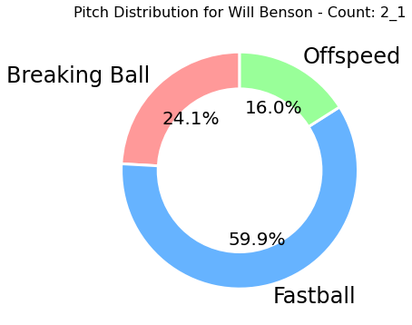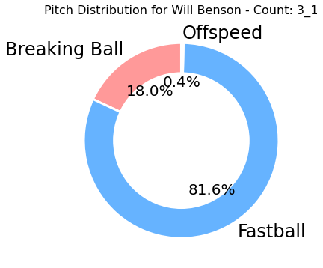

The sequence of the AB after the first pitch OS, OS, OS, FB. After going up in the count it is a bit strange that Benson’s off speed frequency almost triples. It is also a bit strange that his 2-1 frequency is as high as the 1-0 frequency and then see’s virtually no offspeed 3-1 pitches. Soroka has a similar pattern with the exception of his 2-1 OS rate being almost equal to his 0-0 rate. The only other AB that lined up with one of these counts for Benson in the game was a 2-1 pitch that was a fastball.

More season long testing needs to be undertaken to confidently inform batters how they should change their expected pitch mix in a given at bat. In this stage the season-long data in tandem with the pitch count knowledge could be used to help batters hedge what pitch they expect.

**Line-ups**

Having a diverse line-up of projected pitch mixes creates pressure on the opposing pitcher to keep experimenting with different pitch types even if they aren’t comfortable doing so in a game.

Three of the first four batters in game 15 of 2024 for the Reds and their predicted fulls season pitch mixes are listed below. Christian Encarnacion-Strand was 3rd in the lineup but due to a lack of 2023 data he was excluded.

| Batter | Fastball % | Breaking % | Offspeed % |
| --- | --- | --- | --- |
| **Jonathan India** | 59.81% | 30.43% | 9.76% |
| **Will Benson** | 57.23% | 30.64% | 12.13% |
| **Spencer Steer** | 64.67% | 26.62% | 8.71% |

The season long projections are a light guide to what to expect the batters mix to be. Steer can expect to receive more fastballs than Benson. Benson can expect to see more Offspeed pitches than Steer. The season long projections should be used to set lineups. For similar reasons why you wouldn’t want three left handed hitters in a row you also wouldn’t want three batters with significant Offspeed % in a row.

For example Elly De La Cruz expecting a 48/33/19 (FB/BB/OS) split should be adjacent to someone similar to Steer or India in the line up. If the opposing team has a reliever who has an arsenal of a cutter and changeup it would potentially be beneficial to induce a more predictable sequence.

**Player Evaluation**

The surprising part of the model was how insignificant a player's performance on a singular pitch type was. Performance on a certain pitch type had very little bearing on how frequently they would receive that pitch type in the following season. If the coaching staff was specialized in improving an individual pitch type the front office could find value in players that otherwise might not exist.

Hypothetically if the coaching staff excels in improving the quality of contact against changeups a wider pool of free agent options could arise. The front office armed with the model can see what players are expected to receive the highest rate of changeups compared to the rest of the league and pursue acquiring them.

The top 5 players by expected OS rate are:

| Batter | Year | FB% | BB% | OS% |
| --- | --- | --- | --- | --- |
| BrujÃ¡n, Vidal | 2024 | 0.537157 | 0.171078 | **0.291766** |
| Cruz, Oneil | 2024 | 0.402113 | 0.327379 | **0.270508** |
| Hamilton, David | 2024 | 0.504582 | 0.22977 | **0.265647** |
| Bell, Josh | 2024 | 0.533681 | 0.232244 | **0.234075** |
| Brown, Seth | 2024 | 0.477003 | 0.295267 | **0.22773** |

As tempting as trading for one of the division rivals top young stars is, the other four options may be more attainable. Even if the coaching staff has no significant advantage in offspeed pitch coaching, the diversity in the lineup can create harder to manage situations for the opposing team.

**Conclusion**

The batter pitch mix model allows the team to focus on making more accurate in game decisions. The team now can create a more diverse line-up to take advantage of weaker elements of the opposing pitchers arsenal. Surprisingly the model found little correlation between performance and expected pitch mix. Knowing that certain players are going to see more of a certain pitch type regardless of how they perform provides an opportunity to build a team around what pitches they are expected to see and what strengths the coaching staff has to complement those tendencies.